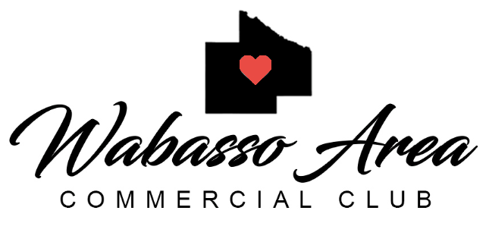

Annual Meeting
12:00 p.m. meeting Tuesday January 10th, 2023
Location: Roadhouse
713 Main Street, Wabasso, MN 56293

Call to Order:
*Members in Attendance: Tina Eis, Nathan Baune, Nathan Jacobson, Jon Fulton, Jamie Taylor, Tiffany Eichten
*Read and Approve Minutes
*Officers Report:
President:
Vice President:
Treasurer:
Outstanding Bills:
Current Balance:
$2,819.19 Year End Balance
$2,733.64 Today’s Balance
Sign Balance:
$7,494.87
Savings Balance:
$11,270.66

Secretary:

*New Business
*2022 Year in Review (Reverse Raffle, Winterfest)
Reverse Raffle – 159 Tickets sold, 150 Attended, 227 Drinks were served at Happy Hour
Income; $9,381
Expenses: $3,861.15
Profit: $5,515.85

Winterfest –
47 Scavenger Hunt Cards Picked-up
57 Bingo Cards Picked-Up
125 Santa Bags Handed out

Expenses: $433.78
Fireworks: $4185.00
Total Expenses 22: $4.618.78

*2022 Officer Review
Tina Eis made a motion to keep all officers the same with exception of Vice president, which Jon Fulton was elected to take the spot of Nathan Baune who stepped down. Tiffany Eichten seconded the motion and all were in favor.

*Committee Updates:
*Welcome
Want to continue again. Looking into having the city help with handing out.
*Membership
Passed out a list of potential members – each potential member will be contacted by someone from the commercial club.
Dues were sent out on January 5th and are due by February 14th. Membership remains $75 – each membership includes a spot on the mailer, 2x/year advertising on the digital sign, and a spot on the city website.
*Digital Sign - Midway Creative
*Winterfest
*Reverse Raffle – Date is set for Friday February 10th. Tickets include Happy hour from 6-7, meal and a chance to win $1500. Tickets for this are $40/person. Do not need to be present to win. There will also be a meat raffle and a card drawing throughout the night instead of a silent auction.

*Other -
*Adjourn

*Future Dates:

- Reverse Raffle February 10th starting at 6 p.m.
- Regular Meeting Feb 14th at 12:00

“The mission of the Wabasso Area Commercial Club is to develop community relationships, promote local communities and support members.”

